Matlab Library

By

Mohammed Abdelkawy Mohammed Abdelkawy

CEI 38 intern at the ITI

Modified False Position Method

Code With Comments:

function [root,fx,Err,iter]=ModifiedFalsePosition(func,xa,xb,es,maxit)

if nargin<3
error('at least 3 input arguments are required')
end
test = func(xa)*func(xb); % check change in sign(if no change there are no roots)
if test>0
error('no sign change - no Roots - change interval')
end
if nargin<4||isempty(es)
es=0.0001 % Default value es = 0.0001
end
if nargin<5||isempty(maxit)
maxit=50; % Default value for maximum number of iteration = 50;
end

% Initial values
iter = 0; % incremented by 1 in the Main loop;
xr = xa; % initial value of root = xa;
Err = inf; % initial value of error = infinity;

%Main Loop
while (Err >= es && iter <= maxit)
xrold = xr;
xr = xb-(func(xb)*(xa-xb))/(func(xa)/2-func(xb));
iter = iter + 1;
if xr ~= 0
Err = abs((xr - xrold)/xr) * 100;
end
test = func(xa)*func(xr); %check change in sign
if test < 0
xb = xr;
elseif test > 0
xa = xr;
else
Err = 0;
end
end
root = xr; fx = func(xr);

Example:
%ModifiedFalsePositionScriptFile
func=@(x) x.^2 - 2.*x -3;
xa = 2;
xb = 3.2;
es = 0.0001;
maxit = 50;
[root,fx,currentError,iter] = ModifiedFalsePosition(func,xa,xb,es,maxit)

Simple Fixed-Point Iteration:

Reference:
Applied Numerical Methods with Matlab for Engineers 4th Ed- chapter 6

Code with comments:
function[xr] = fixedPoint(func, x0, etol)
% Fixed Point Method for calculating root
% Reference (Applied Numerical Methods with Matlab for Engineers 4th Ed-
% chapter 6)
% i: iteration number
% xr: root value for each iteration
% error: (new value of xr - old value )/ old value
title = 'i xr error';
line = '---------------------------------';
fprintf('%s\n',title);
fprintf('%s\n',line);

%initial values for error and number of iterations
nit = 0;
err = inf;

%Main loop
while(err > etol)
nit = nit + 1; %increment iteration by 1
x1 = double(subs(func, x0)); %substitute x0 in the function to claculate new value of xr
err = abs((x1 - x0)/x1);
fprintf('%.f %.4f %.4f\n', nit, x1, err);
x0 = x1; % put the new value in the old value variable and repeat iteration
end
xr = x1;
fprintf('%s\n', line);
end

Example to solve:
% Fixed Point Script File
% example 6.1 in(Applied Numerical Methods with Matlab for Engineers 4th
% Ed - chapter 6)
clear;
clc;
syms x;

func1 = exp(-x);
x0 = 0;

xr = fixedPoint(func1, x0, 0.00001)

Successive Over Relaxation Method
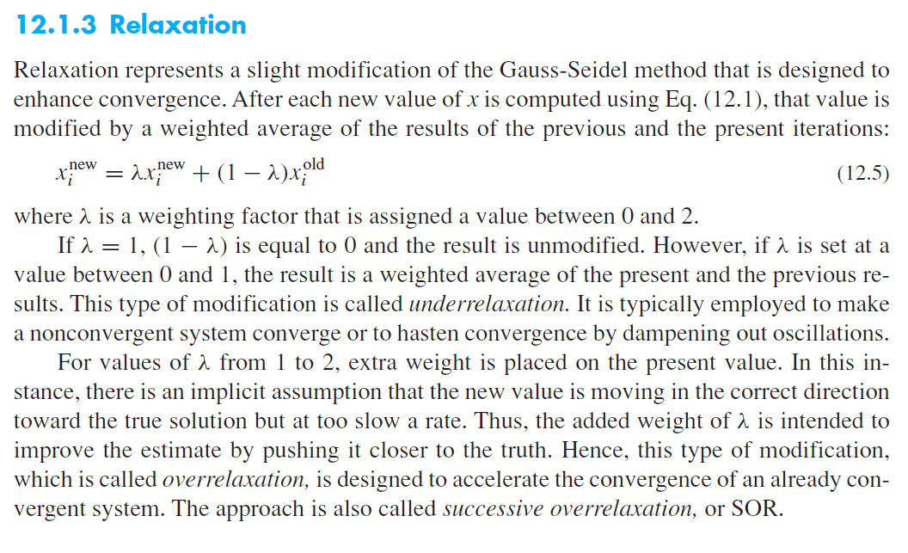

Reference:
Applied Numerical Methods with Matlab for Engineers 4th Ed- chapter 12

Code with comments:
function xr = SOR (A, b, w, tol, maxit)
% Successive Over Relaxation Method
% x = SOR(A, b, w, tol, maxit)

% Reference (Applied Numerical Methods with Matlab for Engineers 4th Ed-
%%% Input:
% A: Coefficient Matrix
% b: Right hand side vector
% w: is a weighting factor that is assigned a value between 0 and 2.
% tol: stop criterion (default = 0.00001%)
% maxit: Maximum number of iterations (default = 100)

%%% Output:
% x = Solution Vector

%%% Check inputs
if nargin < 2
error('At least two arguments required');
end

if nargin < 5 || isempty(maxit)
maxit = 100; %Default Value
end

if nargin < 4 || isempty(tol)
tol = 0.00001; %Default value
end

if nargin < 3 || isempty(w)
w = 1.0; % Default Gauss-Seidel if w == 1.0
end

% DETERINE MATRIX SIZE
[m, n] = size(A);

if m~= n
error('[A] must be a square matrix')
end

C = A;

for i = 1:n

C(i, i) = 0; %diagonal elements
x(i) = 0; % initial guess
end

x = x'; %Transpose x
for i = 1:n
d(i) = b(i)/A(i, i);
end

iter = 0;
while(1)
xold = x;
for i = 1:n
x(i) = d(i) - C(i,:)*x;
xr(i) = w.*x(i)+(1-w).*xold(i); % value of x after multiplying by w
if x(i) ~= 0;
err(i) = abs((xr(i) - xold(i))/xr(i)) * 100;
end
end
iter = iter + 1;
if max(err) <= tol || iter >= maxit
break
end
end

Example:
%SOR Testing Script File
% Reference (Applied Numerical Methods with Matlab for Engineers 4th Ed
%Example 12.1
%Define [A] and [b]
A = [3, -0.1, -0.2; 0.1, 7, -0.3; 0.3, -0.2, 10]
b = [7.85, -19.3, 71.4]
xr = SOR (A, b, 1, 0.000001, 100)
%%%%%%%%%%%%%%%%%%%%%%%%%%%%%%%%%%%%%%%%%%%%%%%%%%

Eigen Quadrate

Code With Comments:
function [E , steps ] = eigQR ( A )
% Computes eigenvalues of a matrix using the QR method .
% Input : A - square matrix
% Outputs : E - vector of eigenvalues
% steps: the number of iterations it took
[ m, n ] = size ( A );
if m ~= n
warning ('The input matrix is not square.')
return
end
% Set up initial estimate
H = hess ( A );
% H = hess(A) finds H, the Hessenberg form of matrix A.
% [P,H] = hess(A) produces a Hessenberg matrix H and a unitary matrix P
% so that A = P*H*P' and P'*P = eye(size(A)) .
% check mathworks website

E = diag ( H );
change = 1;
steps = 0;
% loop while estimate changes
while change > 0
Eold = E ;
% apply QR method
[ Q, R ] = qr( H );
H = R * Q ;
E = diag ( H );
% test change
change = norm ( E - Eold );
steps = steps +1;
end
end

Problem Example:
% Eigen value problem ScriptFile
A=[1,-3,3;3,-5,3;6,-6,4]
[E , steps ]=eigQR(A)

Newton-Cotes

Reference
https://en.wikipedia.org/wiki/Simpson%27s_rule

Code with Comments
function [result] = Simpson38(x,fx)
% Numerical integration of discretized data by
% Simpsons 3/8 rule;
% x = discretized independent data
% fx = discretized dependent data
nPoint = length(x);
% nPoint = calculate number of discrete points (must be odd)
if (nPoint ~= length(fx)), error('Mismatch'); end
nStep = (nPoint - 1)/3;
if (rem(nPoint - 1,3) ~= 0), error('Data count doesn`t fit with formula 3*n+1, where n any positive integer'); end
%initlize result = 0
result = 0;
for k = 1:nStep
ii = 3*k - 2;
h = x(ii+1)- x(ii);
%get sum (3h/8)fm = 3hs/8 [ f(i) + 3f(i=0,1,2) + f(3,6,9)odd)
result = result + 3*h/8*(fx(ii) + 3*fx(ii+1) + 3*fx(ii+2)+ fx(ii+3)) ;
end
end

Example:
% f = 2+cos(2sqrt(x));
f=@(x) 2+cos(2*sqrt(x));
x=linspace(0,2,10);
fx=f(x);
[result] = Simpson38(x,fx)

Gauss Quadrate Method

Code With Comments
function [ Ig ] = GaussQuadrateTwoPoint( a,b,fx )
% calculate integration between two points
% by gauss quadrature integration
% a: first point of step
% b: second point of step
h=b-a;
m=(a+b)/2;
gs=@(s) h/2*fx(m+h/2*s);
Ig=gs(1/sqrt(3))+gs(-1/sqrt(3));
end

Least Square Regression

Code with Comments
function [ a ] = LeastSquareRegression( x,y,degree )
[nr,nc]=size(x);
xnr=max(nr,nc);
xnc=min(nr,nc);
[nr,nc]=size(y);
ynr=max(nr,nc);
ync=min(nr,nc);
if xnr~=ynr,error('x and y must have the same length'),end
if xnc~=1,error('x must be a vector'),end
if ync~=1,error('y must be a vector'),end
n=degree+1;
if xnr<n,error('not enough variables for required regression'),end
A=zeros(n,n);
B=zeros(n,1);
XX=zeros(n+1);
for i = 1:n+1
for j=1:xnr
XX(i)=XX(i)+x(j).^(i-1);
end
end
for i = 1:n
for j=1:n
A(i,j)=XX(i+j-1);
end
end
for i=1:n
for j=1:xnr
B(i)=B(i)+y(j).*x(j).^(i-1);
end
end

a=A\B;

end

Nearest Neighbour Method

Code with comments:
function [ result ] = NearestNeighbour( x,y,ynew )
% Function Nearest Neighbour takes input x as a vector
% the values of y of vector and the the point to find its nearest solutions
% check input data at first compare xnrows with ynrows to make
% sure both are of the same length and check if the xncols & xnrows must
% always be equal to 1 else the program is terminated, ynew must be less than or equal
% to x(1) and greater than x(nrows) else it's out of range
% we start the loop by seeting the value of cuurent(i) equal to the i
% a is equal to x(i) and b is equal to x(i+1) , we check if ynew is
% greater than a and ynew is less than or equal to b if true the loop is
% stopped, then check if (ynew-a) is less than or equal to
% (b-ynew) if true result is equal to y(currenti), else result is equal to
% y(currenti+1) , then the program is terminated.
[nrows,ncols] = size(x);
xnrows = max(nrows,ncols);
xncols = min(nrows,ncols);
[nrows,ncols] = size(y);
ynrows = max(nrows,ncols);
yncols = min(nrows,ncols);
if xnrows ~= ynrows,error('x and y must have the same length'),end
if xncols ~= 1,error('x must be a vector'),end
if yncols ~= 1,error('y must be a vector'),end
if xnrows == 1,error('enter more than one point'),end

if ynew>=x(1) && ynew<=x(xnrows)
for i = 1:xnrows-1
currenti = i;
a = x(i);
b = x(i+1);
if ynew >= a && ynew <= b,break,end
end

if (ynew-a) <= (b-ynew)
result = y(currenti);
else
result = y(currenti+1);
end
else
error('out of range');
end

end

Example:
% Lab Example:
% x interval = 0.50;
x=[0 .5 1 1.5 2 2.5 3 3.5 4];
% y = e^x;
y=[1 1.648721271 2.718281828 4.48168907 7.389056099 12.18249396 20.08553692 33.11545196 54.59815003];
ynew=2.25;
[ result ] = NearestNeighbour( x,y,ynew )

